# CS 340 README

**About the Project/Project Title**

This project is a fully fledged client/server application designed to provide analytics insights to the client. It utilizes MongoDB and Python to build a fully functioning web application enabling exploration of Animal Shelter Data.

## Motivation

Grazioso Salvare is an international rescue-animal training company. A trained rescue dog can rescue humans or other animals in life-threatening conditions. Every day these animals make a difference. To identify dogs for training, Grazioso Salvare has reached an agreement with a nonprofit agency that operates five animal shelters in the region around Austin, Texas.

In the interest of their mission, this nonprofit agency has provided Grazioso Salvare with the data from their shelters. Leveraging this Data, Grazioso Salvare can more efficiently identify candidates for this training process.

## Getting Started

To get a local copy up and running, follow these steps.

1. Setup a local instance of MongoDB.
   1. Create a dedicated user called ‘aacuser’ that only interacts with the ‘aac’ database. A screenshot of a computer program

      Description automatically generated
   2. Test functionality of user account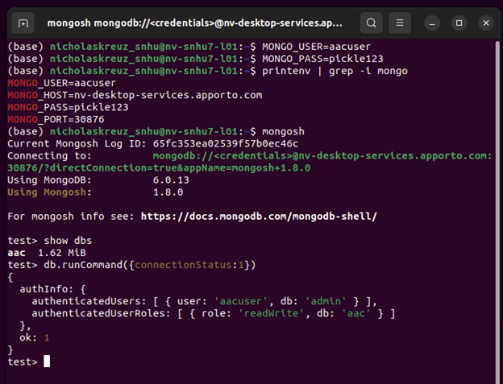
   3. Upload the .csv of the animal shelter data to that database. A screenshot of a computer program

      Description automatically generated
2. Access the MongoCRUD.py and setup.py file.
   1. Update the Connection Details to match your local MongoDB instance. (MongoCRUD.py)A computer screen with white text

      Description automatically generated
   2. Create a distribution description (setup.py) A screen shot of a computer

      Description automatically generated
   3. Generate a distribution file.
      1. WindowsA white paper with text and black text

         Description automatically generated
      2. UNIXA diagram of a programming language

         Description automatically generated
   4. Install the Distribution File
      1. WindowsA close-up of a computer screen

         Description automatically generated
      2. UNIXA close-up of a computer screen

         Description automatically generated
3. Verify functionality by running the Jupyter notebook “MongoCRUD Test.ipynb” A screenshot of a computer

   Description automatically generated

## Installation

System Requirements:

MongoDB is a NoSQL databased favored for its flexibility in storing and managing diverse data. It scales easily with data volume and complexity, which is essential for dynamic datasets like animal shelter records.

* MongoDB v6.0.13 or higher is recommended to take advantage of the latest in database performance and features, supporting the application’s robust data processing needs.

Python is selected for its simplicity and the powerful data handling capabilities it offers. The language’s wide-ranging support for databases and data visualization makes it ideal for backend to frontend development.

* Python v3.5 or higher.
  + ‘pymongo’ is the Python driver for MongoDB, enabling straightforward database interactions.
  + ‘bson.objectid’ is used for managing MongoDB document identifiers, ensuring each document is uniquely stored and accessed.
  + ‘jupyter’ or ‘notebook’ is used to manage and run test scripts in an interactive environment, which allows for clear demonstration and live testing of code snippets via Jupyter Notebooks.

## Usage

### Challenges

*Setting up the Environment initially can be difficult. I had to recompile the MongoCRUD module twice since the network details were not configured properly the first time. Paying extra attention to detail is crucial to ensure connection to the database instance.*

*Additionally, figuring out the Create and Read functionality took a bit of document diving. MongoDB functions differently from the traiditonal Relational Databases I’ve dealt with in the past. Familiarizing myself with Query Structure was a unique challenge.*

### Code Example

The MongoCRUD package provides functionality to Create, Read, Update, and Delete items from the MongoDB aac database animals collection.

**Import:**



**Available objects:**

The MongoCRUD has the AnimalShelter Object available to it.

**AnimalShelter Methods:**

**Create**:

Pass a JSON formatted set of data into the shelter object using the create function.

**Read**:

Pass a JSON formatted search query into the shelter object using the read function.

### Tests (MongoCRUD Test.ipynb):

## Roadmap/Features (Optional)

1. Implement the Update and Delete Functionality of the MongoCRUD package.
2. Develop the Analytics Dashboard to assist in identifying candidates for animal rescue training.
3. Launch a fully functioning Analytics Dashboard on a webpage.

## Contact

Your name: Nicholas Kreuziger